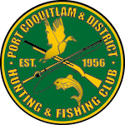
Declaration For New Members

- I have read the “New Members Course: Member Study Materials” governing members of the Port Coquitlam and District Hunting and Fishing Club (PCDHFC).
- I understand that I will not be allowed to commence any range activities at PCDHFC facilities without having read these materials and must present this completed form before being allowed to engage in any range activities.
- I understand that I will not be able to supervise any guests (non-members) without having completed the New Members Course.
- I understand that I must register for, attend and complete the PCDHFC “New Members Course” successfully at the earliest opportunity to assist me in the reading and understanding of PCDHFC’s rules, policies and safety regulations.

Signed,
Name
______________________________ Date _____________
Member number
______________________________
Questions or concerns
Please write the President pres@pcdhfc.com
or Board ℅ secretary@pcdhfc.com

